Joel Atkinson
January 14, 2026
CSD-430 Server Side Development
Assignment 2.2
Code for .JSP file:
<%--
Joel Atkinson, January 14 2026, CSD430 Server Side Development Assignment 2.2
The purpose of this assignment is to create a .jsp file program that uses HTML tags outside of Java Scriptlets that
creates a table with data to be displayed. For my data I chose my favorite cities that I have visited around the world
and included 9 cities with 4 data point fields per city. I also created a CSS Stylesheet to style my page.
--%>
<%@ page language="java" contentType="text/html; charset=UTF-8"
pageEncoding="UTF-8"%>
<%@ page import="java.util.ArrayList" %>
<!DOCTYPE html>
<html>
<head>
<title>My Favorite Cities I Have Visited</title>
<link rel="stylesheet" href="assignment_2_2.css">
</head>
<body>
<!-- Header Section -->
<div class="header">
<h1>My Favorite Cities in the World that I Have Visited</h1>
<p>
This page lists some of my favorite cities that I have visited around the world.
The table below displays the city name, country, year visited, and my favorite
activity while visiting each location.
</p>
</div>
<hr class="gold-divider">
<%
// Java Scriptlet creates data for my favorite cities
ArrayList<String[]> places = new ArrayList<>();
places.add(new String[]{"Munich", "Germany", "2023", "Drank beer at Oktoberfest"});
places.add(new String[]{"Hallstatt", "Austria", "2023", "Explored the beautiful town"});
places.add(new String[]{"Honolulu", "USA", "2022", "Visited Pearl Harbor"});
places.add(new String[]{"Houston", "USA", "2018", "Attended the Houston Rodeo"});
places.add(new String[]{"Rome", "Italy", "2023", "Drank wine across from the Colosseum"});
places.add(new String[]{"Niagara Falls", "Canada", "2020", "Took the Maid of the Mist"});
places.add(new String[]{"Positano", "Italy", "2023", "Boat tour along the Amalfi Coast"});
places.add(new String[]{"Banff", "Canada", "2020", "Horseback riding through the Rocky Mountains"});
places.add(new String[]{"Orlando", "USA", "2025", "Took my daughter to Disney World"});
%>
<!-- Main Content Section -->
<div class="content">
<h2>Favorite Cities Table (9 Records)</h2>
<table>
<tr>
<th>City</th>
<th>Country</th>
<th>Year Visited</th>
<th>Favorite Thing I Did While There</th>
</tr>
<%
// Java Scriptlet loops through records and outputs data in table
for (String[] place : places) {
%>
<tr>
<td><%= place[0] %></td>
<td><%= place[1] %></td>
<td><%= place[2] %></td>
<td><%= place[3] %></td>
</tr>
<%
}
%>
</table>
<h3>Field Descriptions</h3>
<ul>
<li><strong>City:</strong> The main city or area I visited</li>
<li><strong>Country:</strong> The country the city is located in</li>
<li><strong>Year Visited:</strong> The year I visited the location</li>
<li><strong>Favorite Thing I Did While There:</strong> My favorite activity or experience</li>
</ul>
</div>
</body>
</html>

Code for CSS File:
/*
Joel Atkinson, January 14 2026, CSD430 Server Side Development Assignment 2.2
The purpose of this assignment is to create a .jsp file program that uses HTML tags outside of Java Scriptlets that
creates a table with data to be displayed. For my data I chose my favorite cities that I have visited around the world
and included 9 cities with 4 data point fields per city. I also created a CSS Stylesheet to style my page. */
body {
font-family: Arial, sans-serif;
background-color: #eaeaea;
color: #000;
margin: 0;
line-height: 1.6;
}
.header {
background-color: #5b2c83;
padding: 40px 20px;
text-align: center;
}
.header h1 {
color: #DAA520;
margin-bottom: 15px;
}
.header p {
color: white;
max-width: 900px;
margin: 0 auto;
font-size: 1.1em;
}
.gold-divider {
border: none;
height: 4px;
background-color: #DAA520;
margin: 0;
}
.content {
background-color: white;
padding: 40px 20px;
}
h2, h3 {
color: #000000;
text-align: center;
}
table {
width: 85%;
margin: 30px auto;
border-collapse: collapse;
box-shadow: 0 4px 8px rgba(0,0,0,0.1);
}
th {
background-color: #5b2c83; /* Purple */
color: #DAA520;
padding: 12px 15px;
text-align: left;
}
td {
padding: 12px 15px;
border-bottom: 1px solid #ddd;
color: black;
background-color: white;
}
tr:hover td {
background-color: #DAA520;
color: #5b2c83;
}
ul {
max-width: 900px;
margin: 30px auto;
font-size: 1.05em;
}

Screenshot of .JSP file running with server connected:
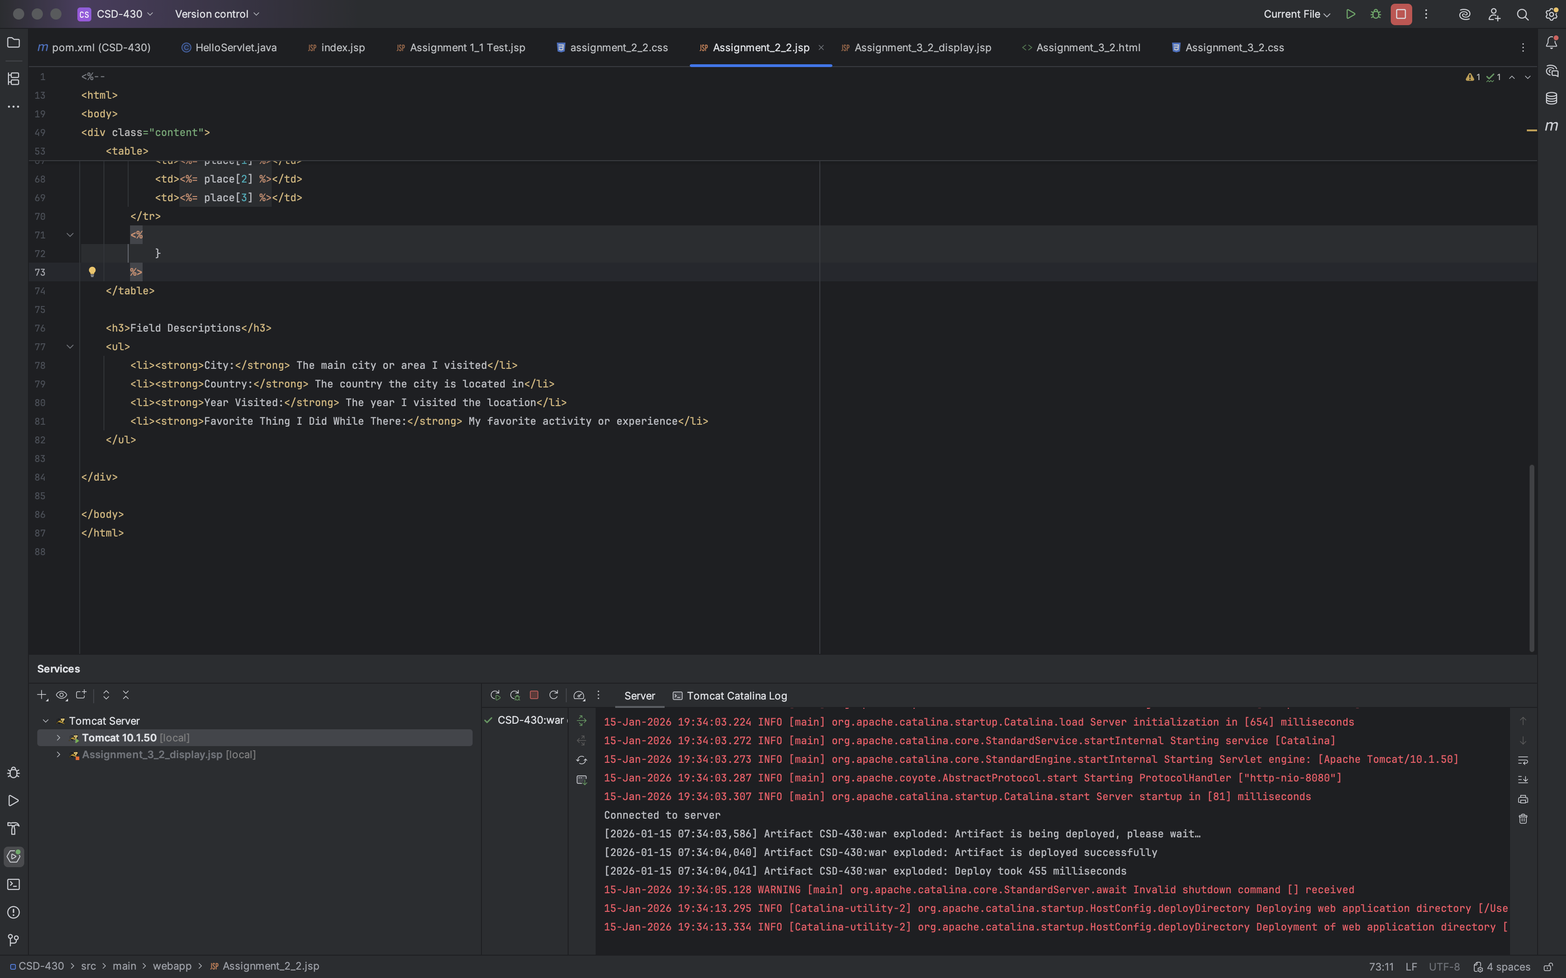

Screenshot of Output of .JSP file running in browser:
